Attorney Feedback: Quick Reference Guide
Having a strong culture of continuous feedback is not just energizing—it’s liberating. Knowing your colleagues are being honest with you will give you greater confidence to take risks and grow, trusting your team has your back. Once you experience that culture, you never want to work any other way. In Chapter 16 of All Rise, I lay out the principles and tactics for building this culture brick by brick. Below is a brief summary of core concepts from that chapter.

The Continuous Feedback Culture

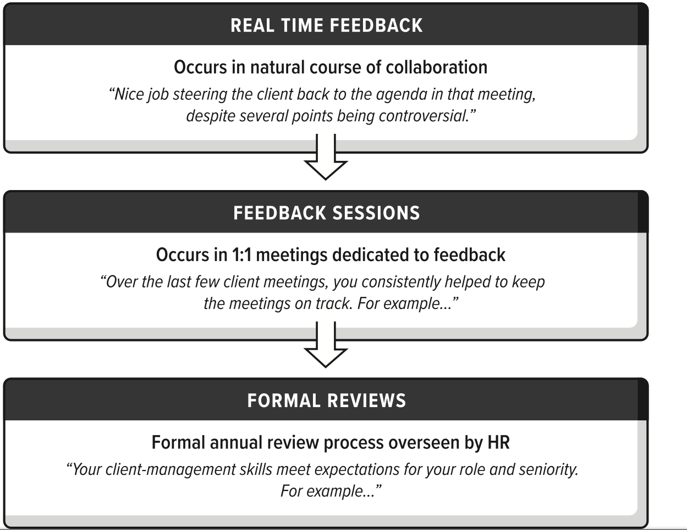

When in doubt, keep in mind these guiding principles:
- In feedback conversations, assume others have good intentions
- Quality feedback is concrete, actionable, and supportive
- Feedback should flow in all directions, regardless of seniority
- Formal reviews should not contain surprises

Framing Feedback with COIN
Context | Set the stage for this conversation. | “Now that the deal closed, I’d like to share some feedback about your work on the disclosure schedule.”
Observations | Focus on the facts, removing emotion and interpretation. | “The disclosure schedule took longer than expected and did not include X and Y. I also did not see any communication from you to the client following up to get that information.”
Impact | Explain the “so what,” e.g., how the behavior affected others | “Because the disclosure schedule was delayed, it caused a ripple effect of delays on other workstreams.”
Next steps | Turn this into a discussion about what could be different next time.  - “Next time, try…”  - “Does what I said make sense?”  - “What was your intention?”  - “How can I help?” | “There was a lot on your plate for this deal. How did you sequence priorities?”  “Can you walk me through your process for reviewing the disclosure schedule?”  “How can I help in the future? Would it have been better if I had _________?”

Constructive Language Examples
NOT: “You lack attention to detail.” | Instead: “I noticed a few typos in your draft. What is your process for reviewing your work?”
NOT: “You are too timid.” | Instead: “When the client asked about your section, you deferred to me to answer. But that was an opportunity to build your credibility.”
NOT: “You aren’t being collaborative.” | Instead: “When you rejected Mike’s idea without explanation, did you notice him visibly stiffen? It happened in meeting X and Y as well. Next time…”

Tips for Soliciting Better Feedback
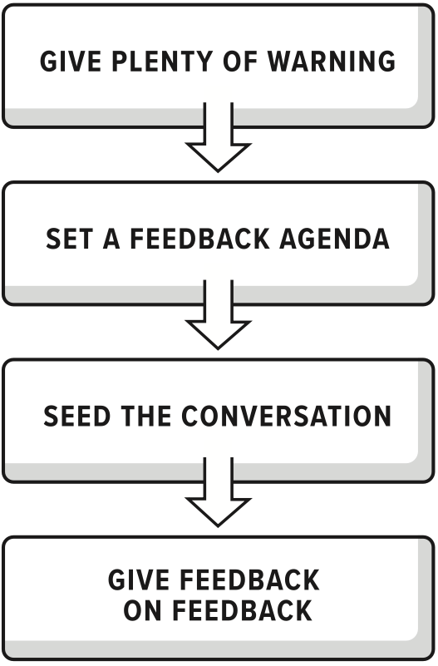 | "Next Tuesday, I put 30 minutes on your calendar to discuss feedback. can move it back if you need more time to prepare."
 | "Next feedback session, I'd be interested in specific feedback on X, Y, and Z, on top of anything else you want to discuss."
 | "I'd like your thoughts on how I handled the last few client calls. Sometimes, I worry I am pushing too hard. What do you think?"
 | "In recent feedback sessions, we focused mostly on the positive. More concrete, constructive feedback would ensure I do not have blind spots or stagnate in my growth."

