Working Style Differences
Social Styles theory was developed by two psychologists, David Merrill and Roger Reid, in the 1960s. Merrill went on to found a company, TRACOM, that commercialized the research. The information provided here is intended for educational purposes and is not affiliated with TRACOM, but they offer a wealth of resources for purchase, if appropriate for your budget, including their official Social Styles assessment.
The goal here is not to make you an expert in Social Styles; instead, the goal is to walk away with concrete examples of how the nuances of personality differences can have a tangible impact on how we work together as attorneys—and how to leverage that insight to become better team members and leaders.
In the diagram below, you will see four Social Styles laid out on a simple two-axis chart. The styles are determined based on two scores: one for assertiveness (x-axis) and one for responsiveness (y-axis). In this context, a highly “assertive” person is direct and intentional, more goal-oriented, and wants control of a situation, while someone with a lower degree of assertiveness will ask more questions, be more patient, and listen. A person who is highly “responsive” is more in touch with their emotions, prioritizing personal connections and stories rather than just facts and logic; a less responsive person might find emotional engagement tedious or excessive and will put personal conversations off until after the work is done. (This is an oversimplification, but these basic differences should be easy to imagine.)

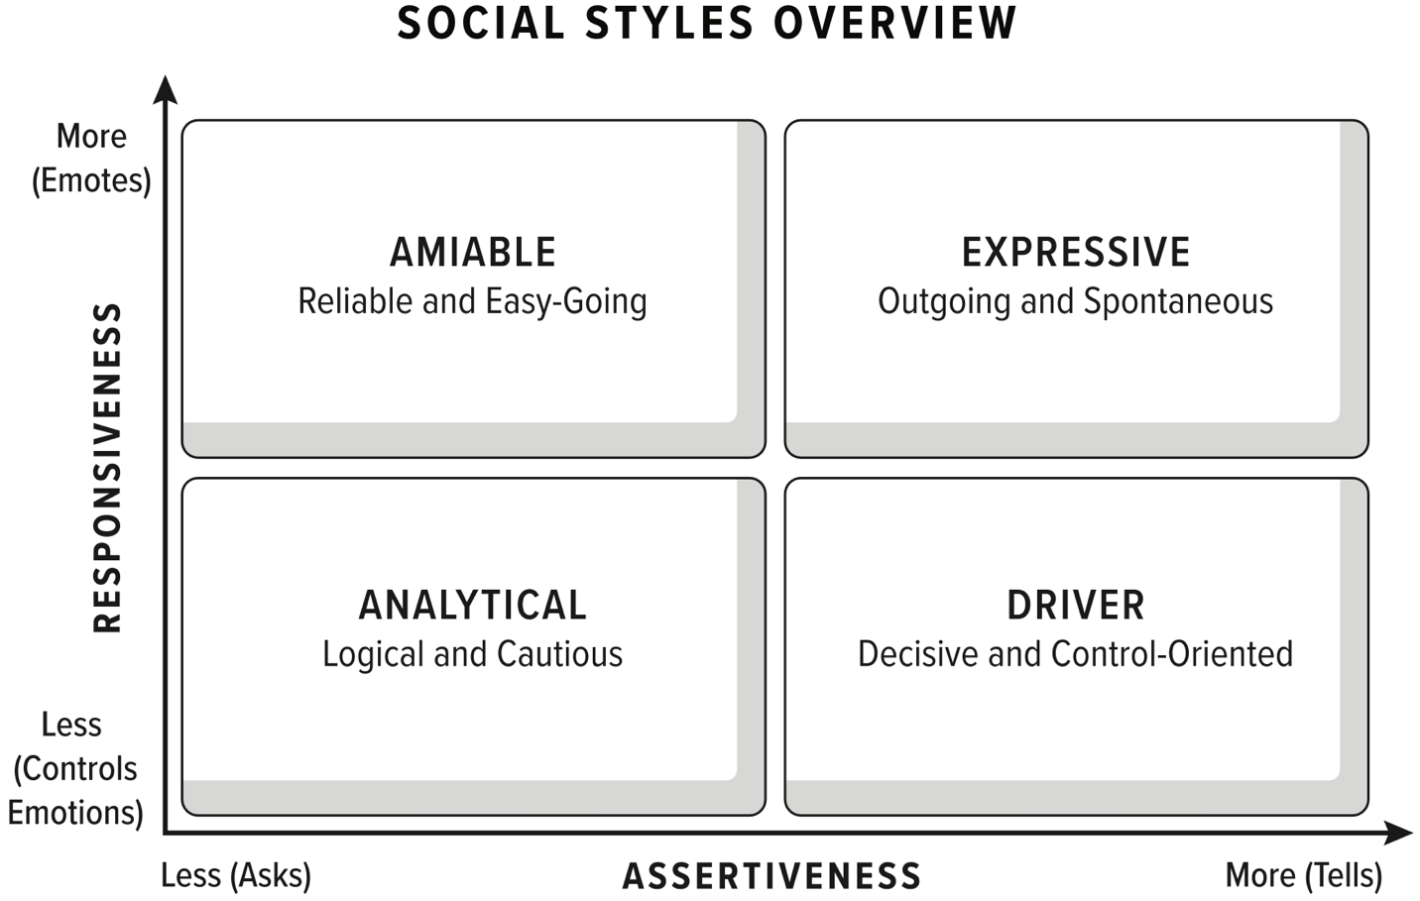
As you glance at this grid, you may be able to identify yourself (or some colleagues) fairly quickly. You can find a richer description of the styles in Chapter 3 of All Rise. This exercise is not about trying to put yourself “in a box” but rather developing greater self-awareness about your natural style and tendencies.
Once you understand your own style, you can consider how differences between you and your colleagues can impede trust and collaboration. For example, below are tips for adapting to your counterpart’s Social Style. Before reading through each list, imagine a boss, colleague, or client that you sometimes struggle to convince. Then consider if these tips might make it easier to connect with that person.
Tips for Working with Analyticals
- Sit side-by-side to focus them on the problem, not the person, e.g., together in front of a whiteboard or screen
- Structure ideas into lists and outlines
- Explain thought processes, e.g., factors you considered, what research you did that got you to this conclusion, or how you gathered your data
- Build your argument based on evidence and data, not storytelling
- Clearly cite sources and be prepared to answer probing questions about them
- Avoid emotional appeals

Tips for Working with Drivers
- Provide clear agendas and be explicit about the goals for the meeting or the decisions you want to resolve
- Come with proposals, not just questions
- For complex topics, include an executive summary upfront with key insights and recommendations
- Stay in control when meetings get derailed by either explicitly altering the agenda to include the topic or tabling it until later
- End with clear action items, including names and deadlines for each

Tips for Working with Amiables
- Ease into controversial topics, making clear you are open to feedback
- Provide a pre-read to ensure time for the amiable to prepare thoughts
- When supervising an amiable, be more detailed with instructions and clear expectations
- Create space for questions and directly ask for their input/feedback
- Allow time to process, especially with complex subjects, e.g., circling back the next day to check for lingering questions or concerns
- Thank them for ideas and feedback

Tips for Working with Expressives
- Allow time for personal connections and conversations, e.g., start with small talk
- Sit across from them, allowing plenty of eye contact
- Listen for and acknowledge personal stories
- Focus on the big picture
- Tell a story, rather than just dumping facts and data
- Avoid too much process

